# Variables

## Question: 1

Variables allow us to:

Name different parts of our programs

Use english words to communicate with Tracy

Store information to use in our programs

Change the words Tracy recognizes

## Question: 2

Which program will have Tracy move forward 10, then turn left and move forward 20?

distance = 10

forward(distance)

left(90)

distance = distance * 2

forward(distance)

distance = 10

forward(distance)

left(90)

forward(distance)

distance = 10

distance = distance * 2

forward(distance)

left(90)

forward(distance)

distance = 10

forward(distance)

left(90)

forward(distance)

distance = distance * 2

## Question: 3

Which of the following programs would produce this output?

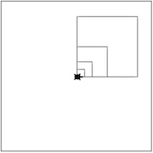

square_length = 20

for i in range(4):

forward(square_length)

left(90)

square_length = square_length * 2

square_length = 20

for i in range(4):

for i in range(4):

forward(square_length)

left(90)

square_length = square_length * 2

square_length = 20

for i in range(4):

forward(square_length)

left(90)

square_length = square_length * 2

square_length = 20

for i in range(4):

for i in range(4):

forward(square_length)

left(90)

square_length = square_length * 2